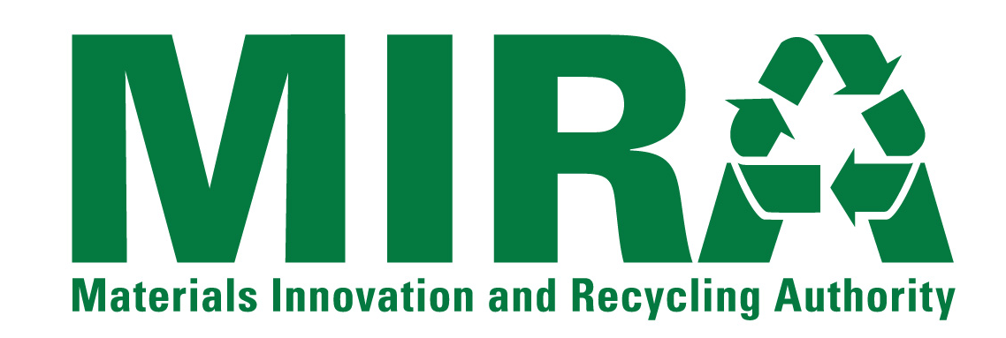
BUSINESS EXCEPTION FORM
Using this form (add additional sheets of paper as needed) and the electronic version of the draft CSWS South Meadows Units 5 and 6 Power Purchase Agreement (the “Agreement”) provided by MIRA, the Statement of Qualifications Submitter (hereinafter referred to as “Contractor”) shall identify any portion of the activities, requirements, and provisions required or described in the RFQ Package Documents including the Agreement that Contractor desires to take exception to, if any.
Contractor shall be specific regarding any exceptions listed and/or redline changes made to the Agreement. Proposer shall describe in detail the portion(s) of the Agreement terms that the Contractor is taking exception to and why. Contractor shall also describe what, if any, alternative services, terms, or conditions Contractor is willing to provide or accept as a substitution for the terms, or conditions to which Contractor has taken exception, if any.
If Contractor does not take exception to any portion of the RFQ Package Documents or to any terms of the Agreement, Contractor shall simply indicate below that Contractor “takes no exceptions”, and submit this form along with the other RFQ forms as part of its SOQ submittal.
Note that MIRA will negotiate with Contractor on only those items identified by Contractor on this Business Exception Form and/or the redlined Agreement, if applicable. Also note that acceptance of any revisions to the terms and conditions of the Agreement, if any, will be at MIRA’s sole discretion. Also note that pursuant to State of Connecticut statutes and regulations, the Agreement contains a number of provisions that MIRA, as a quasi-public entity, is required to incorporate in all of its contracts and are, therefore, non-negotiable.
Description of Exception Item |  | Reason for Exception | Proposed Alternative
1.
2.
3.
4.
5.
6.
7.
8.

